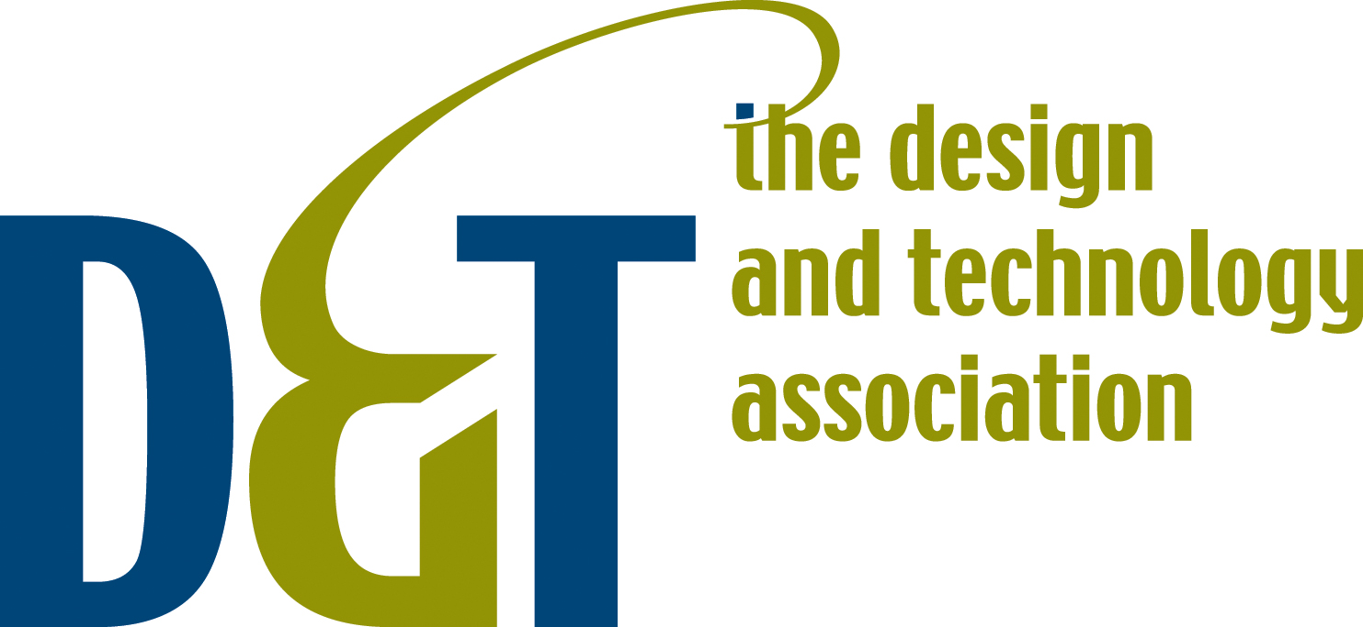

e-Mature Learning in Design and Technology

e-Mature Learning in Design and Technology

Introduction

Design and Technology has long been recognised as making a significant contribution to the development of an individual’s ICT capability. Design and Technology applies a variety of software, together with a range of hardware, not only to process information but also to manufacture 2 and 3 dimensional products. The development of design and technology capability runs alongside the development of ICT capability and contributes to the individual’s e-maturity. It is both the increased level of sophistication at which the learner can work and the nature and quality of their designing and making arising from a developing e-maturity that is so significant.

Definitions:

- ‘Design and Technology’ - combining practical skills with an understanding of aesthetics, social and environmental issues, function and industrial practices; working as autonomous and creative problem solvers, as individuals and members of a team; to respond to real needs and create innovative solutions capable of being tested in use (adapted from National Curriculum for DT).

- ‘ICT Capability’ - using ICT tools to find, explore, analyse, exchange and present information responsibly, creatively and with discrimination (National Curriculum for ICT).

- 'e-learning' – refers to the use of new and emerging technologies, including mobile and internet based technologies, to enhance learning (see also http://en.wikipedia.org/wiki/E-learning).

- 'e-confidence' - possessing a systemic overview of change using ICT, and a state of readiness in preparing to implement it (NAACE – see also http://www.becta.org.uk/page_documents/leaders/governors/e-confident.pdf).

- ‘e-mature’ - involves the development from knowing how to use a skill to deciding when and how to use a skill (NAACE).

“The e-mature learner will therefore be capable of using ICT effectively, where appropriate, in all aspects of life; and will be able to make decisions about when and where to use IT to best effect, based upon an understanding of how to go about a learning activity; what sort of use of ICT is helpful; who they will work with in an increasingly co-operative working environment – or indeed whether its best to use things other than ICT.” (NAACE e-Mature Learner Report)

Mature Learning in Design and Technology

- Mature learners in Design and Technology are able to use a wide range of appropriate sources of information to develop their ideas and develop fully realistic designs, which can be tested in use. They investigate form, function and production processes recognising the different needs of a range of users and their impact on the environment.

- Using a range of strategies to develop appropriate ideas they make decisions on materials and techniques based on their understanding of the physical properties and working characteristics of materials together with their knowledge and skill of a range of tools, equipment, components and processes. They are able to adapt their methods of manufacture to changing circumstances, providing a sound explanation for any change from the design proposal. Work is planned and organised such that that they can carry out processes accurately, consistently and with precision.

- They communicate ideas, using a variety of media identify a broad range of criteria for evaluating their products, clearly relating their findings to the purpose for which the products were designed and the appropriate use of resources (taken from D&T national Curriculum level descriptions).

Mature learners in Design and Technology start with the problem to be solved and then seek and/or apply their existing knowledge skills and understanding of materials and processes to achieve a workable solution. They are not restrained by a particular material or process and are capable of transferring ideas learned in one focus area to generate ideas in another. Solutions need not always be derivative or rooted in the security of an existing realisation, but rather the free exploration of new ideas may expose the need for new knowledge and skills. Design and Technologists are capable of ‘thinking out of the box’. Fundamentally, Design and Technology concerns satisfying human needs or wants and must therefore depend on interactions with others.

“The priority is to place ‘shaping the environment’ at the core of the curriculum. Concern for the environment links the private environment of room, home and garden with public spaces, buildings, towns, and the wider world of nature. It encompasses every aspect of design, and reaches out from personal values and responsibilities towards big political and ecological issues” (from ‘A design dimension of the curriculum’ - a paper by Ken Baynes delivered at a seminar organised by NSEAD and DATA in July 2006).
.

Using ICT to enhance D&T

The development of new technologies provides for Design and Technology:

- a global information base to facilitate investigation an research;
- enhanced modelling and design tools including spreadsheets, simulations and CAD software which, when combined with rapid prototyping devices, enables 3D iconic modelling;
- new ways of validating designs and testing products prior and after manufacture;
- an expanded range of production equipment, including CNC equipment, which aid precision and more especially, enable repeated accuracy of components;
- new processes, such as those involving applications of digital imagery to improve the quality of finished products;
- new ways of communicating and sharing ideas using internet based (e.g. web sites or ‘blogs’) and mobile technologies (e.g. PDAs to gather data on site and phones quickly to gain user feedback by ‘texting’ );
- a new material in the form of electronic data which can be moved between different application processes and used to create outputs in a variety of materials.
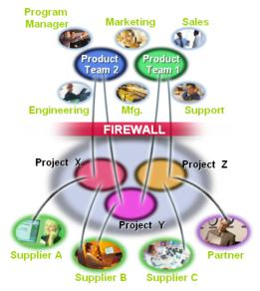

Windchill Project Link – a web based tool to enable product development teams to work together.

“Designing is more than just creating a product! It is also about creating an emotional response!”

(from Designing the Future - 'Awe and Wonder" a presentation to the DATA 2006 international research and education conference by Dr Tony Robotham, Associate Dean, School of Engineering & the Built Environment, Director, Innovative Product Development Centre, The University of Wolverhampton)

Modelling e-Mature Learning for D&T

“An e-mature learner would not be flummoxed when given a new piece of software or an updated version of familiar software. He/she would have some idea what it was supposed to do and would fairly systematically work out how to use it” (NAACE e-Mature Learner Report).

Design and Technologists are risk-takers : they go out into the unknown to create products which as yet do not exist. In doing so, they meet new challenges with a ‘can do’ philosophy and seek ways to solve problems as they arise. They are creative thinkers and persistent problem solvers in search of high quality outcomes. They seek the views of others to analyse problems and evaluate solutions and often work in teams to achieve an end product.

“E-mature learners are first and foremost learners who have learned how to learn and are motivated by learning. They understand concepts, demonstrate higher-order thinking and can make creative links between types and sources of information. Additionally, they are learners who exploit the strengths of modern communications technology in their quest for new knowledge and to broaden and consolidate their existing knowledge”(from The E-mature Learner: A Synopsis of Views, BECTa).

e-Mature Learners in Design and Technology demonstrate:

- sufficient experience of using technology effectively to investigate and research information;
- confidence that they can find solutions to problems and acquire the knowledge and skills necessary to realise them based on their previous successful experience of designing and making quality products ;
- self-direction as they explore alternative ideas, testing and evaluating them as they proceed including the use of ICT to develop design ideas and record and present evaluative data;
- creative use of new and emerging technologies, for example to assist in the production of innovative products from new or traditional materials;
- discernment in choosing the right tool or material for the task given the constraints of initial specification, end user requirements and production quantities;
- emotional maturity in that they are aware of the impact of their work on others and on the environment.
(emboldened key words adapted from The E-mature Learner: A Synopsis of Views, BECTa)

Particular contributions to e-Maturity from D&T

“Design and technology concerns the modern world: it is forward looking. D&T education provides students with opportunities to learn from the achievements of the past, to understand the processes which currently shape the made world, and to become participants in building its future. It is inconceivable that a modern D&T experience should not be enriched by the use of ICT. The Internet now offers D&T departments ready access to world-wide information and services and D&T can give some real purpose to the possibilities offered” (Introduction to ‘DT Online’ – an NAAIDT Guideline).

Ofsted statistics show that Design and Technology teachers are second only to ICT teachers in their use of ICT. D&T is characterised by its readiness to accept and embrace new materials and processes and provides a practical context within which generic ICT skills are put to meaningful use - particularly in the context of investigating, modelling, manufacturing and control.

Design and Technology contributes to ICT capability as follows:

- Finding things out
  - Using data and information sources
    - explore a variety of ICT sources of information to generate ideas taking into account users’ needs and to develop their understanding of familiar products.
  - Searching and selecting
    - obtain data relating to characteristics, working properties and costs of materials and processes as they develop their design ideas.
  - Organisation and investigating
    - devise questionnaires and interviews to elicit the views of consumers, tabulate results and analyse data obtained using ICT applications.

- Developing & making things happen
  - Analysing and automating processes
    - Use component libraries, CAD and DTP, produce designs for products, use CNC equipment and automated processes to produce repeated accuracy.
  - Models and modelling
    - use software simulations or graphics modelling software to investigate ideas and to explore what would happen if conditions were varied
  - Control and monitoring
    - analyse and operate existing systems and use ICT to develop control systems and subsystems to achieve automatic control in own products.

- Exchanging and sharing information
  - Fitness for purpose
    - Exploit a range of software applications to generate, develop, and refine ideas using appropriate drafting conventions and symbols.
  - Refining and presenting
    - Present or display ideas and products to others and at exhibitions exploiting a wide variety of media using ICT based processes
  - Communicating
    - Seek the advice of others using online communications and share ideas by publishing them using Internet based technologies.

Indeed, the ICT capability model is based upon a model for DT Capability first proposed by Black and Harrison:

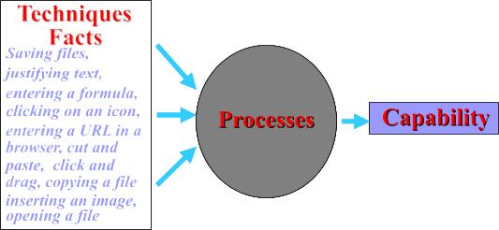

E-maturity in Design and Technology requires an understanding of what technology is available and what it can do but does not start from there. Rather the Design and Technologist would begin with a problem then generate and develop ideas with the confidence of knowing they will be able to find or adapt a suitable ICT-based or other process to realise their designs when needed.

The key to e-Maturity in DT is that learners continue to start with the problem and seek workable solutions but ICT has expanded the toolset and range of materials open to them.

Examples of e-Mature learning through D&T

- Given the task of designing a leaflet in DT: Graphics, an e-Confident student might unhesitatingly explore the available formats in a familiar software application (eg MS Publisher) whereas e-Mature students may start by exploring how many ways they can fold a sheet of A4 paper and, having generated useful shapes (including triangular shapes perhaps) would then seek out software applications that can produce the required outputs.

- e-Confident students can research food packaging on the internet using search engines but e-Mature students would go beyond this to explore analogous solutions such as packaging in nature, packaging from other times and from other cultures. They might use the broad knowledge base now available to them to investigate the technology of edible food packaging and explore if existing solutions for confectionery products (ice cream for example) can be adapted and transferred to hot foods available from ‘fast-food’ outlets.

Design and Technologists strive to understand the technology. When they use Search Engines, they would be discriminating in their selection of information found and note that domains ending in .com, or .co.uk may have a commercial bias whereas .gov, ac, or .org may be free of this (but could have other characteristics to be wary of).

- Students may learn to use control software by following step by set instructions how to use a particular control box as a focused task, but with E-Maturity would go on to solve real problems using an input-process-output model where ICT control is one of several possible options for a solution – and within ICT either remote, computer control or dedicated microprocessor processor are considered e.g. using peripheral interface controllers (PIC logic).

- E-Mature students view common devices in terms of how they can be used to create the outputs required. They will explore the widest range of media that can be fed in to a printer for example (not just paper) and see the printed output as part of a manufactured output rather than an end in itself. (designs for surface treatments designed in the style of well-known artist printed and transferred by heat sublimation printing directly onto metal, plastic fabric ceramic surfaces of products they manufacture).

- They recognise that computer controlled manufacturing equipment is capable of high precision and repeatable accuracy and, once input, design data cab be used many times in to create outputs in different media. They exploit this to engage in ‘enterprise’ type activities involving costed and commercial quality batch production.

- Above all, e-Mature Design and Technologist understand their materials and understand that electronic data is a new material identified by its file type, which can be categorised in terms of characteristics and working properties. Some materials, or file types, are proprietary (like ‘Perspex’ and ‘.xls’) and some more generic (like ‘acrylic’ and ‘.csv’). As with traditional materials, some file types can be used in many processes (or software applications), some can be used across a sub-set of processes and the least universal are locked into a single, often proprietary application (e.g. MS Publisher).

But it is the use of images where perhaps knowing the material can have greatest impact. It is not unusual for even quite experienced ICT users to load images from a scanner or digital cameras directly into a PowerPoint presentation and then be surprised that the resulting file size is several tens of megabytes and far too large to email or post on the Internet – and Broadband is not the answer!

E-Mature users who understand the nature of the material would first ‘cut it to size’ by importing the images into software such as PaintShopPro, XaraX, CorelDraw (or the free GIMP or BIMP offerings) to reduce it and optimise the colour palette for Internet use. They understand that there is no point storing an image at a higher resolution than the intended display medium can support and monitor screens do not demand nearly as much as a printer does.

(Reference to data as a new materials taken from ‘New Material: New Challenges’, by NAAIDT)

Assessing e-Maturity through D&T

“Progression in e-maturity involves developing self-confidence and self-reliance and gradually taking more responsibility for one’s own learning” (The E-mature Learner: A Synopsis of Views, BECTa).

“Assessing e-maturity against the ‘best in show’ If e-maturity consists of being able to transfer knowledge and skills and apply them generally outside the limitations of the context in which they were originally acquired in order to solve new problems, then at any level of knowledge and skills, maturity can be measured by seeing how much of them have been understood and internalised to the extent that they can be applied in new contexts to solve new problems” ((NAACE e-Mature Learner Report).

Progression in e-Maturity, as described, mirrors progression through Design and Technology may be characterised by the following ‘milestones’ between Level 1 and Exceptional Performance:

- Pupils are able to say if they have used ICT to help them with their designing and making
- Use a paint, illustration program or a simple word processor they are familiar with, to describe what they want to do
- Use ICT generated outputs to enrich the creation of manufactured products - e.g. by applying print-outs to create a surface finish.
- Able to use 2D drawing software to produce drawings with sufficient dimensional accuracy and information to aid construction.
- Use computer-controlled equipment to produce high quality components or control a sequence with accuracy.
- Select from a 'toolkit' of software applications to achieve a required output
- Recognising the importance of portable file types, they are able to move electronic data between applications to create outputs in a variety of media
- Able to design a production sequence that integrates the outputs of a range of computer controlled equipment.
- Have sufficient experience of a wide variety of ICT applications to have confidence they will be able to adopt or adapt one to achieve a desired outcome.

“We do not yet have an exam and assessment system that is fit for purpose. That system has to combine pragmatism with vision in creating a workable process that allows for students’ creativity and ambition. Assessment procedures should take more account of ambition and risk-taking within students’ design ideas. Schools and parents should be persuaded of the greater value of such an approach” (Conclusions to ‘Now you see it, now you don’t’ - a seminar organised by NSEAD and DATA in July 2006).

Geoff Howard
November 2006

