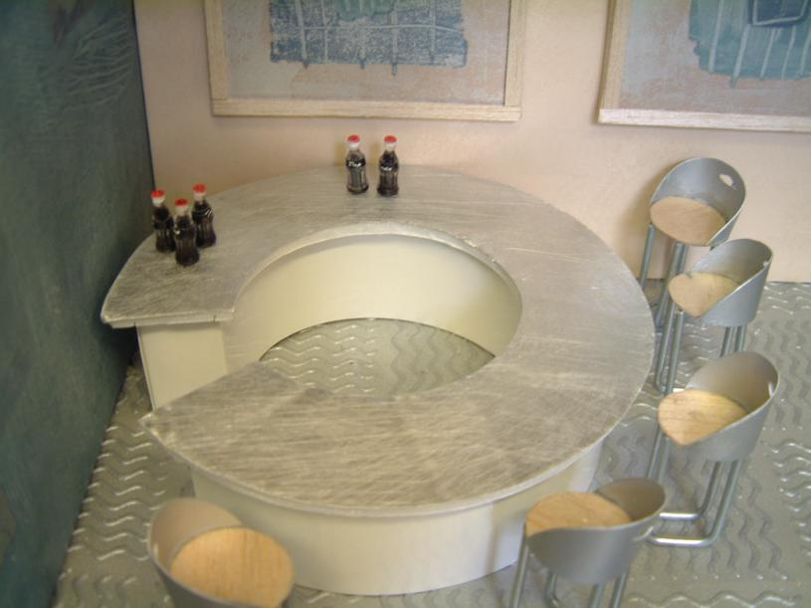
Bar made from stiff card. Bar top is foam board with aluminium sheet that has been sandpapered to give a brushed aluminium look
Flooring is embossed wallpaper from a modern range.
Accessories for dolls houses add a finishing detail
Chair legs made using steel rods and bent on a metal vice with a hammer.

