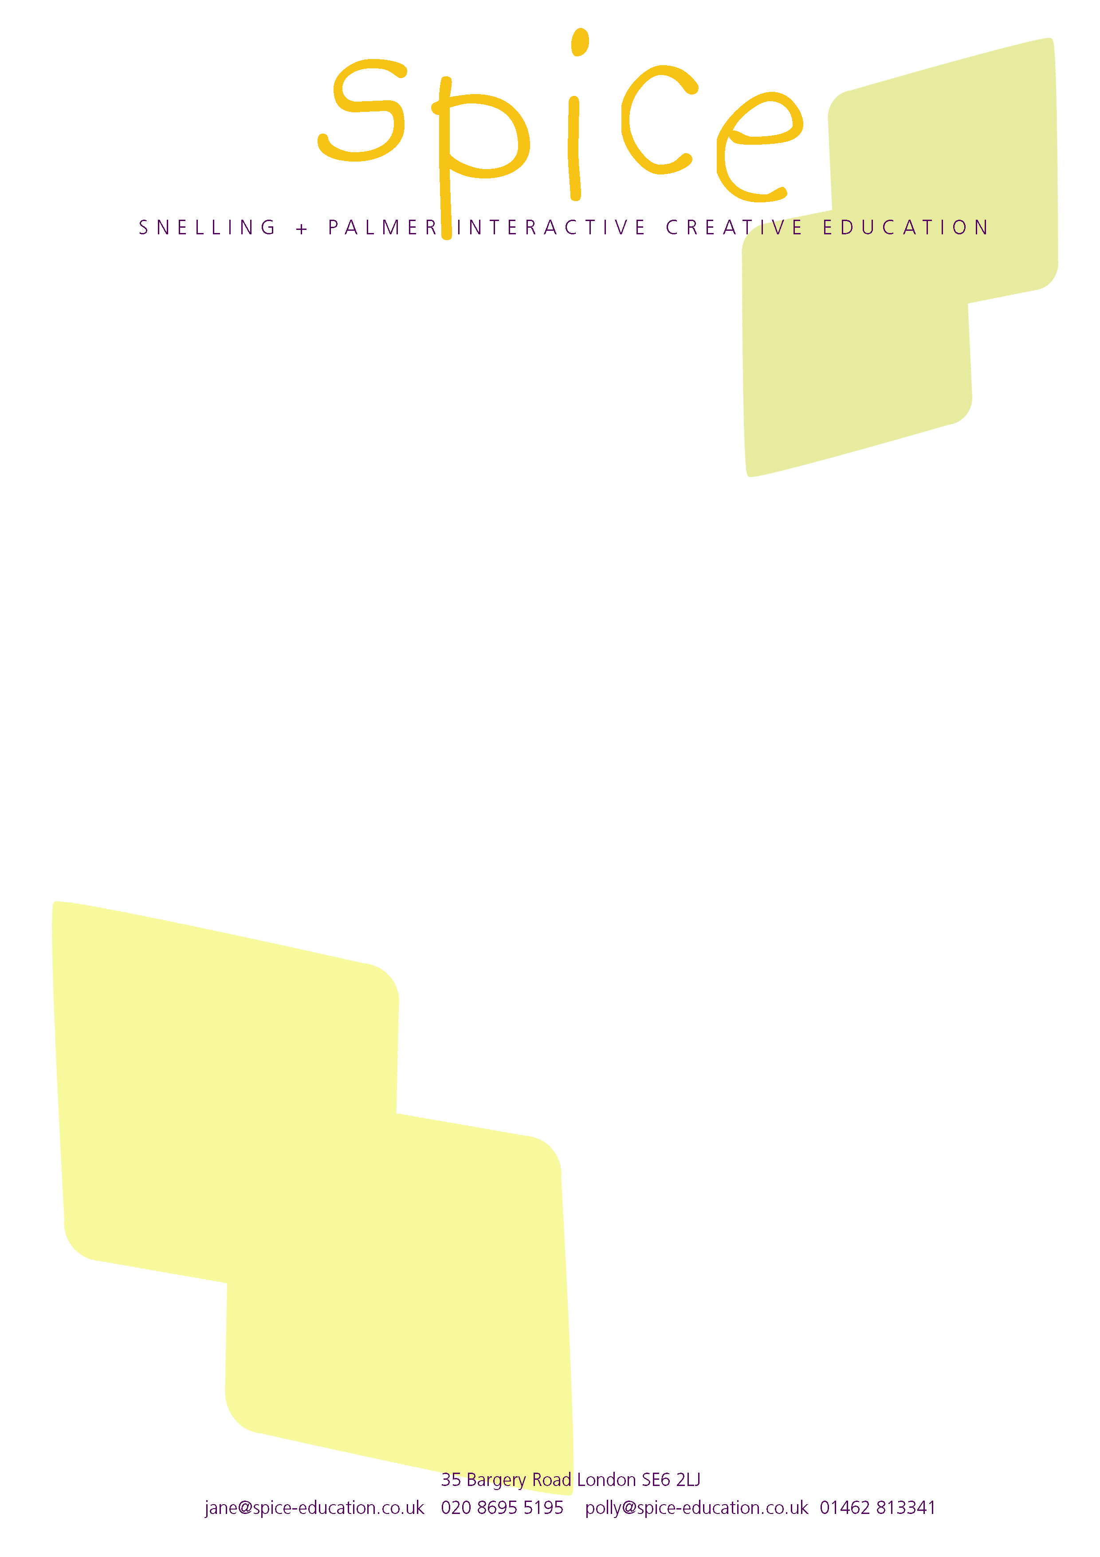
SPICE WORKSHOP

NAAIDT conference 15 April 2005

Product analysis and the Key Stage 3 Strategy

Kicking off with product evaluation

Devising activities that could be used as start-ups, single lessons, or as a springboard for a new project. A hands-on introduction to the principles of product analysis and evaluation, using SPICE handling collections.

1 Mystery collection
A collection of contemporary products whose function is not immediately obvious. Our collection includes affordable products such as Philippe Starck’s Dr Skud fly swat, Ron Arad’s Soundtrack CD holder, and Sebastian Conran’s watering can.

Mystery activity – working in pairs or small groups, pass round the products and brainstorm as many functions as possible in 1 minute.

Mystery products are terrific for getting pupils to think laterally. You can use them alongside more conventional products with the same function to run ‘user trips’, or do comparative evaluations.

2 Product stories collection
Everyday objects with interesting stories. We use Velcro, Post-its, Tupperware and the Bic ballpoint pen. Product stories are great for teaching materials and manufacturing processes, and for innovation, technology transfer, ‘thinking out of the box’, etc.

Product detectives activity – provide each pair with the scenario that led to the invention, e.g the dog getting burrs in its coat on a walk that led to its owner developing Velcro. You might have 4 stories to share with a whole class so that pairs are competing to come up with the answer first.

This activity can be developed to consider the properties of the materials or the way we might use the properties of a man-made or natural artefact in a different situation to innovate.

3 Time line
Make a collection of historic and contemporary products from charity shops, car boots, jumble sales and friends and relatives (who often hang on to unwanted goods for years). Cameras, electrical appliances (kettles, hairdryers, radios), kitchenware, packaging and clothing are all cheap and widely available.

Time line activity - Line up similar products from different eras randomly and get the class standing round the line. Ask pupils to put them into time order. Ask them to think why they are making these decisions and what makes one product look more recent than another. This activity helps show pupils why design decisions are made and how much we take for granted the design of everyday products.
It can be developed to explore user need, anthropometrics, materials and processes and to expand pupils’ design vocabulary.

4 The role of product handling in the Key Stage 3 strategy
A teacher activity exploring the KS3 subskills and how they may be taught through product handling.

This activity makes use of a range of product handling collections. Relevant Year 7, 8 and 9 characteristics from the KS3 National Strategy Framework and training materials have been printed on individual cards.

This activity requires some familiarity with the handling collections being used, for example after a product evaluation session. Distribute two cards from the same year group to participants working in pairs. Ask them to choose one or more products and devise a suitable activity. How would you address the aspects of subskills on your cards using this product?

About Spice
Polly Palmer and Jane Snelling were formerly Education Managers at the Design Museum. We wrote the education resources for the museum and set up the ground-breaking Designers in Action CPD programme.

SPICE provides professional development for teachers and modules for initial teacher training using the same radical and exciting formula. The workshops support vital elements of the new KS3 strategy. We offer similar workshops in school for students from Key Stage 1 to post-graduate level, in Design & Technology and Art & Design.

Since leaving the museum to set up SPICE (Snelling & Palmer Interactive Creative Education) we have produced the popular Polypropylene Resource Pack to support 21st century design skills in the classroom. In 2005 we are launching further resource packs on Lighting and Plastics.

Visit our website for more details: www.spice-education.co.uk

© Spice 2003

